Nick Forleo

SWENG 505

**Portfolio 6**

* Reward Power: 5
* Coercive Power: 2
* Situation Power: 6
* Information Power: 2
* Legitimate Power: 2
* Revenant Power: 4
* Charismatic Power: 4
* Expertise Power: 6

Total: 31

When rating each power, I was applying it in the context of me in the workplace. I am relatively new to leadership roles, so I definitely have more to improve. I try not to be seen as someone with much coercive power, as that is not the kind of leader that I want to be. I am working on building my expertise power, as that is something that I find valuable. I think a good place that I can immediately improve is information power. I can be more proactive in seeking out relevant information that will make me appear more knowledgeable about projects or topics.

**Portfolio 7:**

| Question | Spouse / Friend | Colleague |
| --- | --- | --- |
| 1 | A (1/1) | A (1/1) |
| 2 | A (5/5) | A (5/5) |
| 3 | B (1/9) | A (9/1) |
| 4 | B (1/9) | A (5/5) |
| 5 | A (9/9) | B (1/1) |
| 6 | A (1/1) | A (1/1) |
| 7 | A (1/1) | B (5/5) |
| 8 | B (9/9) | A (9/1) |
| 9 | A (1/1) | B (9/1) |
| 10 | B (5/5) | B (5/5) |
| 11 | B (1/9) | A (9/9) |
| 12 | B (5/5) | B (5/5) |
| 13 | A (5/5) | A (5/5) |
| 14 | A (9/9) | B (9/1) |
| 15 | B (1/1) | B (1/1) |
| 16 | A (1/9) | A (1/9) |
| 17 | B (1/1) | A (9/1) |
| 18 | B (5/5) | B (5/5) |
| 19 | A (9/9) | B (1/1) |
| 20 | A (9/9) | A (9/9) |
| 21 | A (1/9) | B (9/9) |
| 22 | A (5/5) | A (5/5) |
| 23 | A (9/9) | B (1/1) |
| 24 | A (1/9) | A (1/9) |
| 25 | A (9/1) | A (9/1) |
| 26 | B (9/9) | A (5/5) |
| 27 | B (1/9) | A (1/1) |
| 28 | B (9/9) | B (9/9) |
| 29 | B (1/1) | B (1/1) |
| 30 | A (1/9) | B (9/9) |

Spouse/Friend:

* (9/1): 1
* (9/9): 8
* (5/5): 6
* (1/1): 7
* (1/9): 8

Colleague:

* (9/1): 6
* (9/9): 5
* (5/5): 9
* (1/1): 8
* (1/9): 2

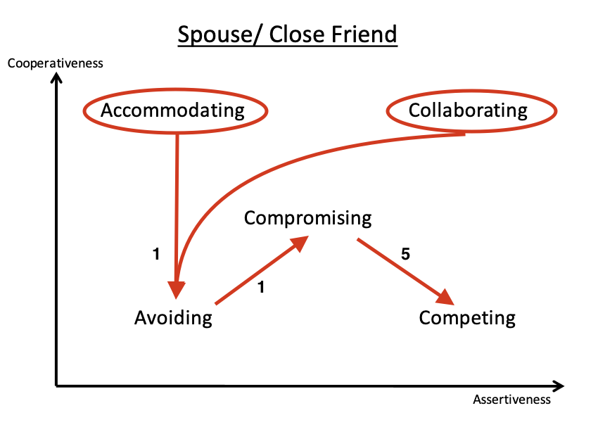

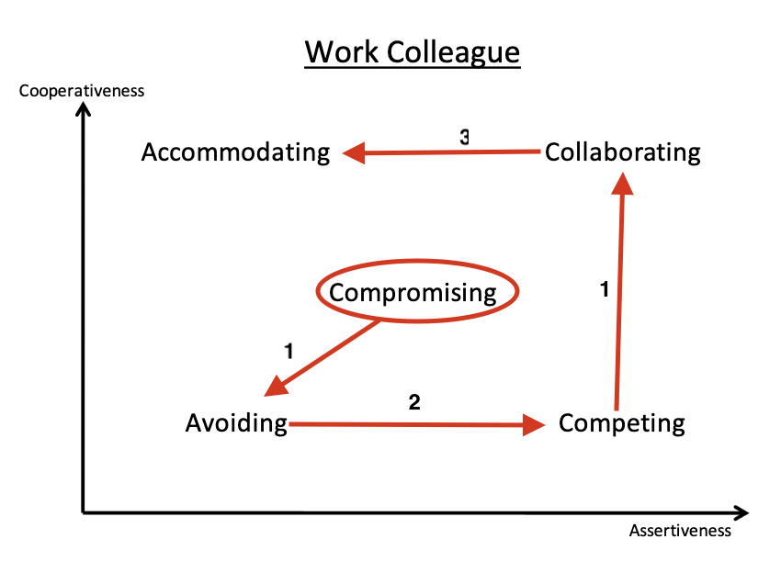

I think that both of these graphs are an accurate representation. When negotiating with a close friend or partner, I do not simply want to “win” the argument at any cost. Therefore, I am more Collaborating and Accommodating. I want to come to a win-win solution while also making sure they feel heard and validated. Preserving the relationship is just as, if not more, important than solving the conflict optimally. I almost never want to compete, which is why the difference is so high.

When dealing with a colleague, I want to work together to find a solution, but in this case, I am not as concerned with their feelings - not saying I don’t care at all - but finding the right solution is more important. So I will work to find a solution that works for both of us, even if that means one of us loses a little. I will do what I can to avoid a conflict if possible. I don’t want work to be a constant source of stress because of negotiating all the time or making sure that I am always right. However, if I feel that my argument is the better solution, I will be sure to put it forth and defend it, since the optimal solution benefits the company, therefore both parties. Easily being able to transition between styles will help to adjust to what is necessary for the given argument/negotiation. In turn, this will lead to better outcomes all around.